St Peter’s English Writing Curriculum EYFS Small Steps
SMALL STEPS | EYFS  
Talk About Your Ideas | Listen attentively and respond to what they hear with relevant questions, comments and actions when being read to and during whole class discussions and small group interactions.  Make comments about what they have heard and ask questions to clarify their understanding.  Hold conversation when engaged in back-and-forth exchanges with their teacher and peers.  Participate in small group, class and one-to-one discussions, offering their own ideas, using recently introduced vocabulary.  Offer explanations for why things might happen, making use of recently introduced vocabulary from stories, non-fiction, rhymes and poems when appropriate.  Express their ideas and feelings about their experiences using full sentences, including use of past, present and future tenses and making use of conjunctions, with modelling and support from their teacher.  Invent, adapt and recount narratives and stories with peers and their teacher.  Sing a range of well-known nursery rhymes and songs.  Perform songs, rhymes, poems and stories with others, and – when appropriate – try to move in time with music.
Write About Your Ideas | Write recognisable letters, most of which are correctly formed.  Spell words by identifying sounds in them and representing the sounds with a letter or letters.  Write simple phrases and sentences that can be read by others.
Handwriting | Develop their small motor skills so that they can use a range of tools competently, safely and confidently. Suggested tools: pencils for drawing and writing, paintbrushes, scissors, knives, forks and spoons.  Hold a pencil effectively in preparation for fluent writing – using the tripod grip in almost all cases.  Write recognisable letters, most of which are correctly formed.
Punctuation | Begin to use capital letters and full stops.
Phonics and Spelling Rules | Autumn Term  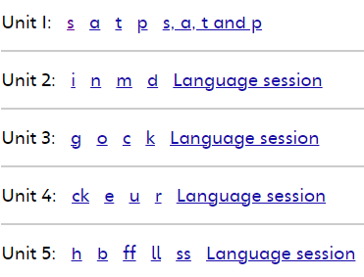  Spring Term  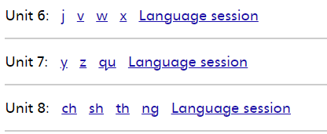  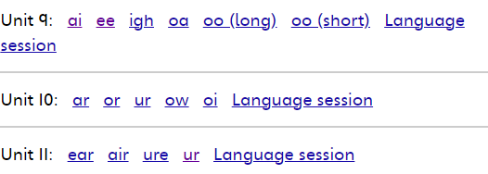  Summer Term  