**How we teach the four operations**

**@**

**St Peter’s Church of England (Aided) Primary School**

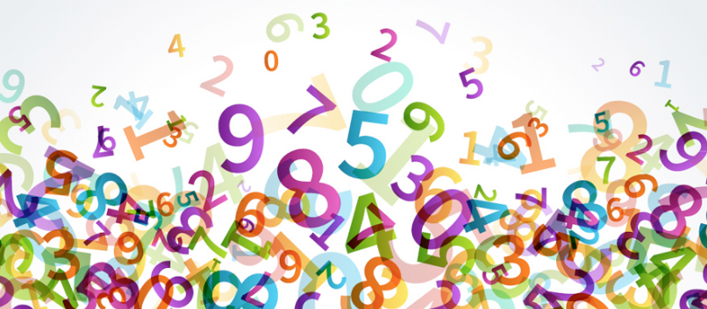

At St Peter’s, maths is made to be fun and relevant, encouraging children to be independent thinkers, mathematical talkers and problem solvers.

We aim to develop procedural fluency in maths through deep and meaningful conceptual understanding.

The written strategies in this booklet are taught consistently alongside a range of mental strategies allowing children to identify the strategy ***they*** wish to use.

**Our Maths Vocabulary**

|  |  |
| --- | --- |
| ***Addition***  Sum  Total  Add  Plus  Increase  Altogether | ***Subtraction***  Subtract  Less  Minus  Find the difference  Difference between  Fewer  Take away |
| ***Multiplication***  Multiply  Times  Lots of  Product  Repeated addition | ***Division***  Divided by  Groups of  Share  Share equally  Remainder |

**Addition**

**Early Addition Skills**

Counting objects reliably

Adding one more

Combining two groups

+ =

3 2 5

Understand that addition can be done in any order

4 + 6 = 10 6 + 4 =10 10 = 6 + 4 10 = 4 + 6

Know number bonds within 10

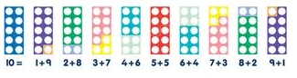

Use a ‘Ten Frame’ to identify number bonds

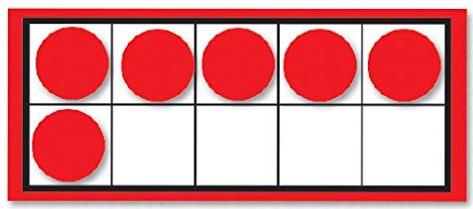

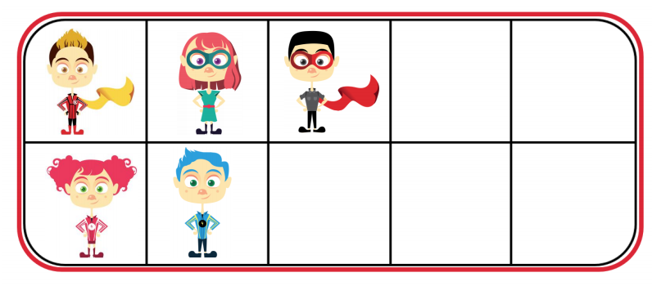

Record addition as a number sentence using symbols

Represent problems in a bar model

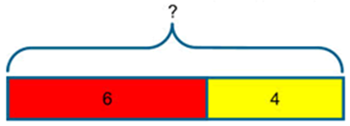

On Monday Bob collects 6 apples. On Tuesday he collects 4 apples. How many apples does he collect altogether?

6 + 4 = 10

Understand addition is the inverse of subtraction and derive related facts

8 + 2 = 10 10 – 2 = 8

Use the inverse to calculate unknown amounts

9 + = 10

**Addition on a Number Line (labelled and unlabelled**

Counting on in jumps of 1

7 + 3 = 10

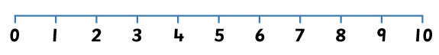

Use partitioning when ***bridging*** a multiple of 10

8 + 5 = 13

+ 2 +3

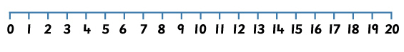

To partition numbers and count on in tens and ones

34 + 15 = 49

+ 10 + 5

34 44 49

136 + 112 = 248

+ 100 +10 +2

136 236 246 248

**Partitioning and Re-combining**

34 + 17 =

4 + 7 = 11

30 + 10 = 40 40 + 11 = 51

**Column Addition**

Expanded column addition

34

15 +

9 (4 + 5)

40 . (30 + 10)

49

**Represent addition with Dienes**

|  |  |  |
| --- | --- | --- |
| Hundreds | Tens | Ones |
|  |  |  |
|  | We need to group the ones together, 4 + 5 = 9.  Then we need to group the tens, 3 tens + 1 ten = 4 tens (40).  ***40 + 9 = 49*** |  |

Compact column addition

59

27 +

86 .

1

|  |  |  |
| --- | --- | --- |
| Hundreds | Tens | Ones |
|  |  |  |
|  |  |  |



9 + 7 = 16. Therefore, we need to ‘***regroup’*** 10 ones as 1 ten and carry it into the tens column. We are left with 6 ones.

We then group our tens together, 5 tens + 2 tens + 1 ten = 8 tens (80)

Compact method for addition - Examples

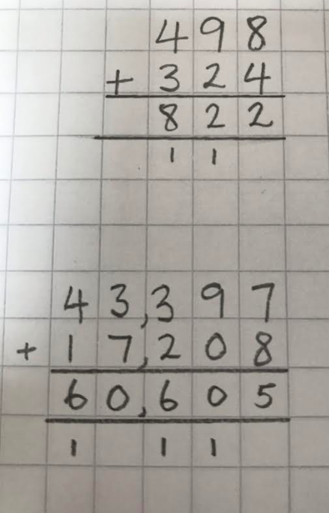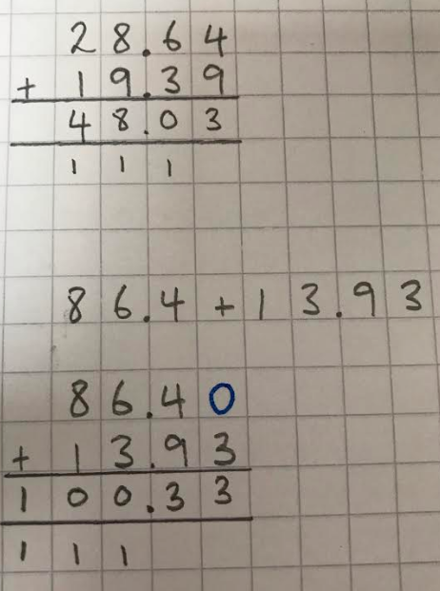

Compact column addition to add integers and decimals

28.7

26.5 +

55.2 .

1 1

**Problem Solving – Examples (with Bar Models)**

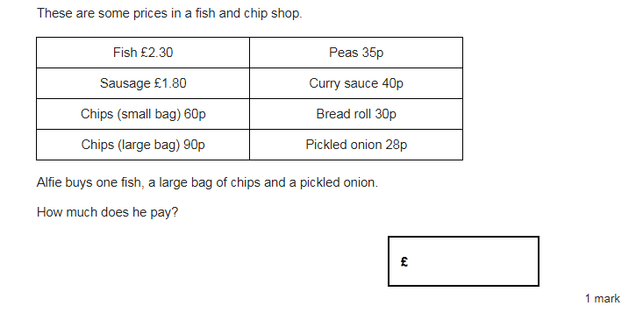

£2.30 90p 28p

|  |  |  |
| --- | --- | --- |
|  |  |  |

?

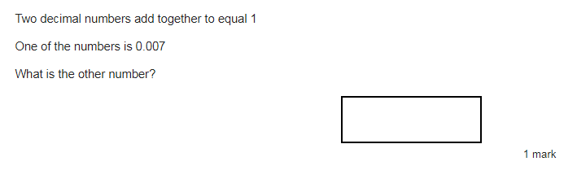

0.007 ?

|  |  |
| --- | --- |
|  |  |

1

Subtraction

**Early Subtraction Skills**

Counting objects reliably

Counting forwards and backwards, including over 10 boundaries

8, 9, 10, 11, 12 22, 21, 20, 19, 18

Understand subtraction as taking away

6 – 2 = 4

 

Understand subtraction as finding the difference

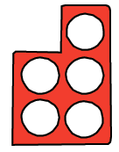 

*“The difference between 5 and 2 is 3”*

Know and use number bonds within 10

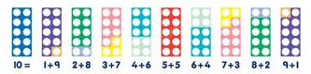

Use a ‘Ten frame’ to identify and calculate with number bonds

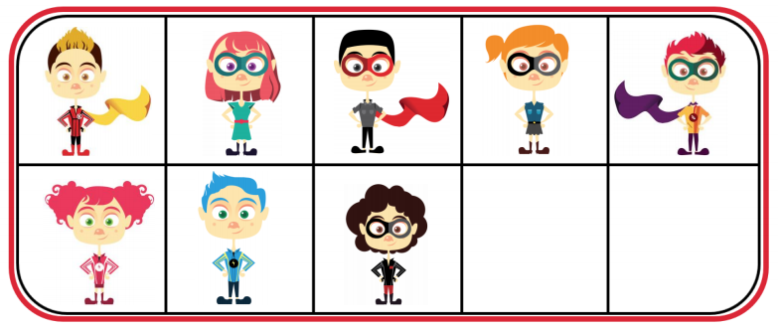

Record subtraction as a number sentence using symbols

12 – 4= 8

? 4

|  |  |
| --- | --- |
|  |  |

12

Understand subtraction is the inverse of addition and derive related facts

10 – 3 = 7 *so* 7 + 3 = 10 *and* 3 + 7 = 10

Use the inverse to calculate unknown amounts

20 - = 9

9 ?

|  |  |
| --- | --- |
|  |  |

20

**Subtraction on a Number Line (labelled and unlabelled)**

Count forwards and backwards in jumps of 1

10 – 3 = 7

*Counting backwards from 10*



10 – 3 = 7

*Counting on from 3*



Using a number line to represent subtraction as ‘taking away’

62 - 15 = 47

-3 -2 -10

47 50 52 62

Using a number line to ‘take’ a 3 digit number from another 3 digit number

452 – 287 = 165

-7 -30 -50 -100 -100

165 172 202 252 352 452

Using a number line to represent subtraction as ‘finding the difference’

62 - 15 = 47 40 + 5 + 2 = 47

Here we have counted to the next ten first.

+ 5 + 40 + 2

15 20 60 62

or…

62 – 15 = 47 40 + 5 + 2 = 47

…multiples of ten first

+ 40

+ 10 + 10 + 10 + 10 +5 +2

15 55 60 62

**Column Subtraction**

85 – 53 = 32

|  |  |  |
| --- | --- | --- |
| Hundreds | Tens | Ones |
|  |  |  |

First you subtract 3 ones, leaving only 2 ones in the ones column.

4 -3 = 1

Then you subtract 5 tens, leaving 3 tens.

80 – 50 = 30

943 - 627 = 316

|  |  |  |
| --- | --- | --- |
| Hundreds | Tens | Ones |
|  |  |  |

First, because we can’t subtract 7 ones from 3 ones, we regroup 1 ten into 10 ones - as shown above.

We then subtract 7 ones from 13 ones.

13 – 7 = 6

We then subtract the tens and hundreds column.

943 – 627 = 475

When we have a secure understanding of the mathematics involved, we will move onto writing the method as shown here.

3 1

9 4 3

* 3 2 7

4 1 6

Subtracting decimal numbers using compact column method

5 1

8 6 . 7

- 4 3 . 8

4 2 . 9

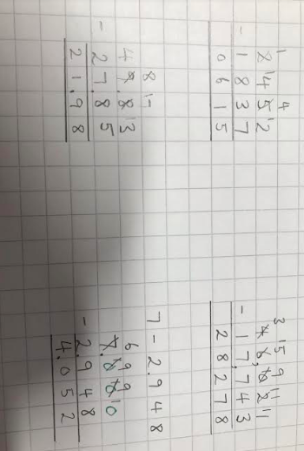

**Problem Solving – Examples (with Bar Models)**

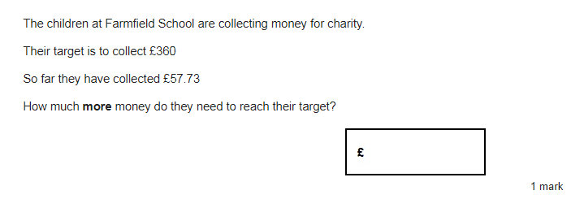

£57.73 ?

|  |  |
| --- | --- |
|  |  |

£360

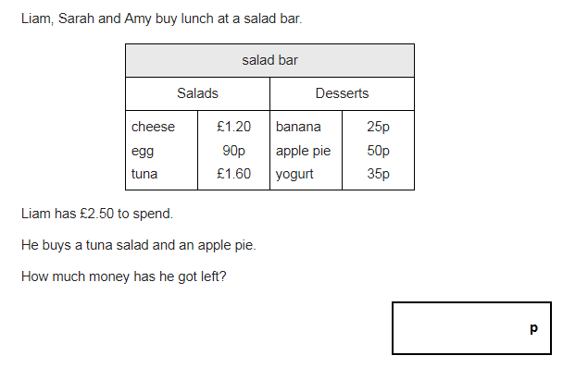

£1.60 50p ?

|  |  |  |
| --- | --- | --- |
|  |  |  |

£2.50

Multiplication

**Early Multiplication Skills**

Counting reliably in different sizes

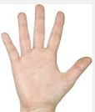 = 20 = 10

5 10 15 20 2 4 6 8 10

Understand doubling 2 equal groups



3 x 2 = 6

3 + 3 = 6





+



+ +

Understand multiplication as repeated addition

  

5 x 3 = 5 + 5 + 5 = 15

5 5 5

|  |  |  |
| --- | --- | --- |
|  |  |  |

15

3 3 3 3 3

|  |  |  |  |  |
| --- | --- | --- | --- | --- |
|  |  |  |  |  |

15

Understand the commutative nature of multiplication

2 x 3 = 6  3 x 2 = 6

Know multiplication facts up to 12 x 12 *(National Curriculum statement for the end of Year 4)*



3 x 9 = 27

4 x 6 = 24

Understand that multiplication is the inverse of division

3 x 6 = 18

6 x 3 = 18

18 ÷ 6 = 3

18 ÷ 3 = 6

Multiply any number by 10, 100 and 1000 using our understanding of place value

63 x 10 = 630

|  |  |  |
| --- | --- | --- |
| Hundreds | Tens | One  We put a zero in the ones column as a place holder. |
|  | 6 | 3 |
| 6 | 3 | 0 |

4.8 x 10 = 48

|  |  |  |  |
| --- | --- | --- | --- |
| Tens | Ones | . | Tenths |
|  | 4 | . | 8 |
| 4 | 8 | . | 0 |

**Multiplication on a Number Line**

6 x 2 = 12

(one digit x one digit)

2 2 2 2 2 2

0 2 4 6 8 10 12

Or…

6 6

0 6 12

36 x 5 = 180

(2 digit x 1 digit)

10 x 5 10 x 5 10 x 5 6x5

0 50 100 150 180

**Grid Method for Multiplication**

17 x 4 = 68

(2 digit x 1 digit)

Step one: Partition the 2 digit number

e.g. 17 = 10 + 7

|  |  |  |
| --- | --- | --- |
| x | 10 | 7 |
| 4 | 40 | 28 |

Step 2: Multiply 4 by 7 = 28

Step 3: Multiply 4 by 10 = 40

40

Step 4: Add together you two answers from step 2 and step 3 to get your final answer

e.g. 40 + 28 = 68

Therefore, 17 x 4 = 68

+ 28

68

500

150

+ 30

680

136 x 5 = 680

(3 digit x 1 digit)

|  |  |  |  |
| --- | --- | --- | --- |
| X | 100 | 30 | 6 |
| 5 | 500 | 150 | 30 |

46 x 13 = 598

400

120

60

+ 18

598

(2 digit x 2 digit)

|  |  |  |
| --- | --- | --- |
| x | 40 | 6 |
| 10 | 400 | 60 |
| 3 | 120 | 18 |

16.4 x 6 = 98.4

(Grid Method to multiply decimals)

If I multiply 0.4 I get an answer of 4. I can then do 6 x 4 = 24

|  |  |  |  |
| --- | --- | --- | --- |
| x | 10 | 6 | 0.4 |
| 6 | 60 | 36 | 2.4 |

60

36

+ 2.4

98.4

Because I multiplied by 10, I must divide the

answer by 10. 24 ÷ 10 = 2.4

**Expanded Multiplication**

243

x 7

We are following the same procedure in these two methods. We start by multiplying the ones, then the tens and finally the hundreds.

21 (7 x 3)

280 (7 x 40)

1400 (7 x 200)

1701

1

**Short Multiplication**

24 x 6 = 136 342 x 7 = 2394

24 342

x 6 x 7

2

1

2

144 2394

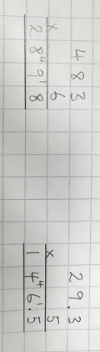

**Long Multiplication**

(2 digits x 2 digits)

24 x 16 = 384

2

6 x 4 = 24 (regroup 20 into the tens column).

6 x 20 = 120 (add the 20 you regrouped earlier = 140)

10 x 24 = 240.

144 + 240 = 384

24

x 16

144

240

**384**

(3 digits x 2 digits)

124 x 26 = 3224

1 2

6 x 4 = 24 (carry 20 into the tens column).

6 x 20 = 120 (add the 20 you carried earlier = 140)

6 x 100 = 600 (add the 100 you carried earlier = 700)

20 x 124 = 2480

744 + 2480 = 3224

124

x 26

744

2480

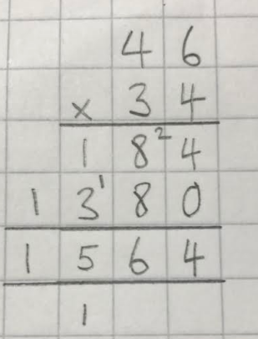 **3224**

1 1

**Problem Solving – Examples (with Bar Models)**

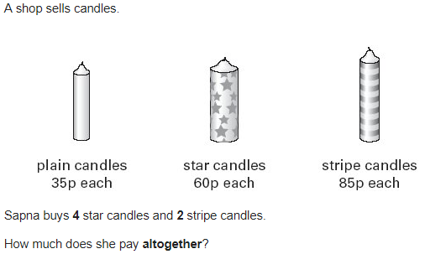

60p 60p 60p 60p

|  |  |  |  |
| --- | --- | --- | --- |
|  |  |  |  |

?

85p 85p

|  |  |
| --- | --- |
|  |  |

?

**Division**

**Early Division Skills**

Counting reliably in different sizes

Understand halving as 2 equal groups

Half of 4 = 2 4 ÷ 2 = 2

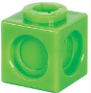   

Understand division as sharing and grouping

8 ÷ 4 = 2 8 in 4 equal groups

8 ÷ 2 = 4 8 shared into 2 equal sets of 4

Grouping

20 ÷ 5= 4

4 groups of 5 = 20

20 in groups of 5 gives 4 groups

Sharing

20 ÷ 5= 4

5 sets of 4 = 20

20 in 5 sets gives 4 in each set

Record division as a number sentence using symbols

Understand that division is the inverse of multiplication

24 ÷ 6 = 4 24 ÷ 4 = 6 6 x 4 = 24 4 x 6 = 24

Divide numbers by 10, 100 & 1000 using our understanding of place value

63 ÷ 10 = 6.3

|  |  |  |  |
| --- | --- | --- | --- |
| Tens | Units | . | Tenths |
| 6 | 3 |  |  |
| 0 | 6 | . | 3 |

63 ÷ 100 = 0.63

|  |  |  |  |  |
| --- | --- | --- | --- | --- |
| Tens | Units | . | Tenths | Hundredths |
| 6 | 3 |  |  |  |
| 0 | 0 | . | 6 | 3 |

**Division on a Number Line**

How many jumps of 2 do I need to reach 8?

8 ÷ 2 = 4

1 2 3 4

2 2 2 2

0 2 4 6 8

31 ÷ 5 = 6 remainder 1

1 2 3 4 5 6

5 5 5 5 5 5 1 0 5 10 15 20 25 30

Chunking on a Number Line

76 ÷ 4 = 19

10 x 4 5 x 4 4 x 4

0 40 60 76

***10 + 5 + 4 = 19***

Chunking with Place Value Counters

84 ÷ 4 = 21

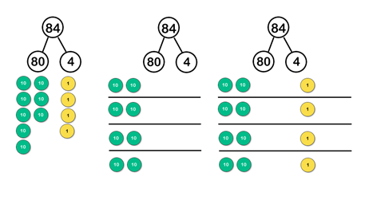

**Short Division**

98 ÷ 7 = 14

1 4

7 9 28

432 ÷ 5 = 86 r 2

0 8 6 r 2

5 4 43 32

***…or…***

432 ÷ 5 = 86.4

0 8 6 . 4

5 4 43 32 . 0

2

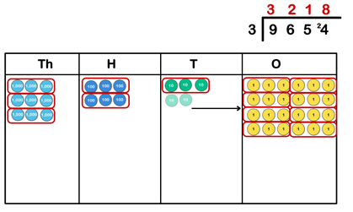We can also represent short division pictorially or with concrete resources

**Long Division**

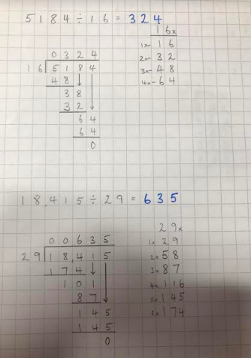

Our 16 x tables to help us!

Step 1:

5 ÷ 16 is less than 1 so we carry the 5 to make 51 ÷ 6 = 3 r 3

3 x 16 = 48

Here is our remainder 3.

Step 2:

We bring the 8 down to join the remainder 3 and make 38.

38 ÷ 16 = 2 r 6

Here is our remainder 6.

Step 3:

We now bring the 4 down to join the remainder 6 and make 64.

64 ÷ 16 = 4

**Problem Solving – Examples**

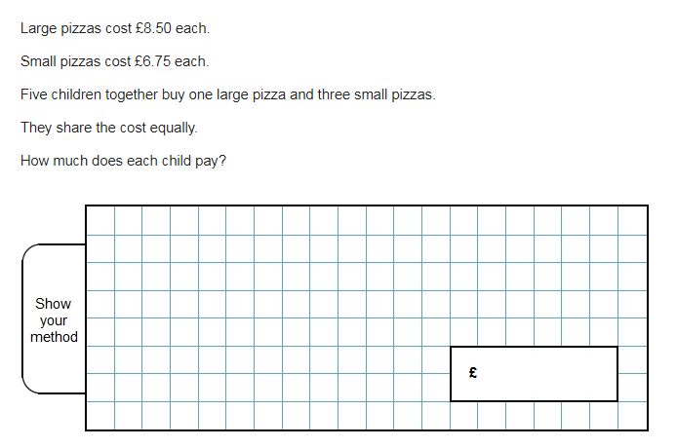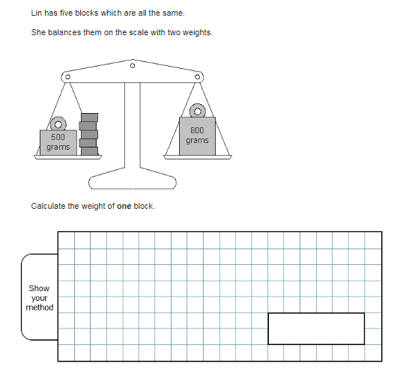

**Glossary of Mathematical Terms**

**Arrays** A set of objects or symbols arranged in rows or columns.

**Bar Model**  A way of representing a maths problem pictorially

**Bridging** Where a calculation requires you to cross a multiple of ten.

**Commutative** The order of the numbers in a calculation can be reversed e.g. 2 + 4 = 6 and 4 + 2 = 6.

**Dienes Blocks** Wooden or plastic cubes, rods and flats used to support children in learning place value.

**Difference** The result of subtracting one number from another. How much one number ‘differs’ from another.

**Digit** Any of the numerals between 0-9

**Factor** Numbers we can multiply together to get another number

**Integer**  A whole number

**Inverse** Reverse operations e.g. addition and subtraction are inverse operations

**Multiple** A number is added to itself a number of times

**Number Bonds** Two numbers that total a whole number

**Number Sentence** A written calculation including an equals sign

**Numicon** a teaching resource designed to help children visualise numbers

**Partitioning** Splitting a number into the value of each digit

**Place Value** The value of each digit in a number depending on its position

**Product** The result of multiplying numbers together

**Re-combining** Adding partitioned numbers back together

**Regrouping** Changing 10 ones for 1 ten, or 10 tens for 1 hundred etc

**Remainder** The amount ‘left over’ after a division calculation

**Sum** To add together

**Tens Frame** two-by-five rectangular **frames** into which objects, e.g. counters, are placed to show numbers less than or equal to **ten**

**Total**  The sum of a set of numbers