 | APPLICATION FOR ENTRY TO  St. Peter’s C of E (Aided) Primary School  Potters Green, off Station Road, Cowfold, Nr Horsham, West Sussex RH13 8QZ  Tel No: 01403 864365  E-mail: office@st-peters-cowfold.w-sussex.sch.uk  Headteacher: Mr Giles Kolter BSc(Hons) PGCE NPQH
ADMISSION ARRANGEMENTS –2020-2021

The School Governing Body is the Admissions Authority for the School. The Governors’ wish is that the school should aim to meet the educational needs of the children of all those families within the village seeking places at the school and of families with children already attending the school before offering places more widely. The Published Admissions Number (PAN) is 20. Where the number of admission applications received is 20 or fewer, a place will be offered for every child without condition. If the number of applications exceeds 20, the order of priority for admission will be determined by the application of the following oversubscription criteria:

Oversubscription Criteria
- A ‘looked after child’ or a child who was previously looked after but immediately after being looked after became subject to an adoption, child arrangements, or special guardianship order. A looked after child is a child who, at the time of application, is (a) in the care of a local authority, or (b) being provided with accommodation by a local authority in the exercise of their social services functions (section 22 (1) of the Children Act 1989 applies). This includes children who were previously looked after but immediately after being looked after became subject to an adoption, residence, or special guardianship.
- Children who have at least one parent who worships at the Parish Eucharist at St Peter’s Church, Cowfold at least twice every month for a minimum period of six months prior to application, and who are resident within the ecclesiastical Parish of Cowfold.
- Children who have siblings at the school at the time of admission and who are resident within the ecclesiastical Parish of Cowfold.
- Children who have at least one parent who attends the main act of worship at another church (which must be a member of the Churches Together in Britain and Ireland or of the Evangelical Alliance) at least twice every month for a minimum period of six months prior to application and who are resident in the ecclesiastical Parish of Cowfold. New residents may apply to their previous church for a reference.
- All other children of parents who are resident within the ecclesiastical Parish of Cowfold.
- Children with siblings attending the school at the time of admission, but who are not resident within the ecclesiastical Parish of Cowfold.
- Children who have at least one parent who worships at the Parish Eucharist at St Peter’s Church, Cowfold, at least twice every month, but who are not resident within the ecclesiastical Parish of Cowfold.
- Children who are not resident within the ecclesiastical Parish of Cowfold, but have at least one parent who attends the main act of worship at another church (which must be a member of the Churches Together in Britain and Ireland or of the Evangelical Alliance) at least twice every month for a minimum of six months prior to application. New residents may apply to their previous church for a reference.
- Any other children not included in the above criteria.

Notes:
- In accordance with National SEN Code of Practice, we will accept any child with St Peter's School named in their Education Health and Care Plan (EHCP) into the school.
- Multiple birth children (for example: twins or triplets) would not be separated. If one child were ranked at number 20 so would all the other children, and the school would exceed its PAN.

Parish Map
A map showing the boundaries of the ecclesiastical Parish of Cowfold can be found at the end of these arrangements.

ADMISSION ARRANGEMENTS –2020-21

Prioritising by straight line Distance
Should insufficient places be available under one of the above criterion for the number of children applying, a distance criteria will be implemented. Priority within each criterion will be established in order of distance from the school in line with the criteria set by West Sussex County Council. In each case, the distance will be measured by straight-line distance from the school to the child’s home address using Ordnance Survey address point data from a central point in each building.

Deadlines & Waiting List
Applications submitted after the national deadline set by the government of 15 January will be considered after places have been allocated to those applications received on time. If the year group is oversubscribed, a waiting list of pupils will be maintained for the main September admissions round. Children on the waiting list, and any additional applicants, will be ranked according to the admissions criteria and each time a child’s name is added, the list will be re-ranked. This will be maintained until 31st December of the same year.

Appeal
There is a right of appeal to an independent panel against a decision made by the governors to refuse admission. Parents wishing to exercise this right should write to the Clerk to the Governors c/o the School. All appeals must be received within 20 school days of the receipt of the letter refusing a place.

Definitions
Governors have agreed the following definitions of words used in this policy:
Parent includes legal guardian.
Church means a church that is a full member of the Churches Together in Britain and Ireland or of the Evangelical Alliance.
Sibling means a full, half or step brother or sister permanently living in the same household, and adoptive or foster brother or sister.
Home address is taken as the main address at which the child resides for the majority of the time.

Deferred Entry to School
While a child is below statutory school age, the parent may choose to defer his/her child’s entry to school until later in the school year. However, parents cannot defer beyond the point at which the child reaches statutory school age, or beyond the start of the last term in the school year.

Full Time or Part Time Start
A parent may apply for his/her child to start school for the first time in the September following their fourth birthday. Where a place is offered, a parent may choose for the child to start full time from day one, or to attend on a part time basis until statutory school age is reached (the start of the term after the child reaches their fifth birthday).

Applications made for children born from 1st April 2016 to 31st August 2016
Parents of a "summer born" child (born between the above dates) who is entitled to start school in September 2020 may request to delay his/her entry and this will receive consideration, although delayed entry may only be granted in very exceptional circumstances. The Headteacher should be contacted prior to any application where a delayed entry might be requested so that discussion of individual circumstances can take place.

Fair Access Protocol
The Governing Body adhere to the Fair Access Protocol as administered by West Sussex County Council.

In-Year Admissions
The Governing Body has delegated administration of In-Year Admissions to West Sussex County Council who will consult with the School’s Admissions Authority.

SUPPLEMENTARY INFORMATION FORM
FOR APPLICATION TO
St. Peter’s C of E (Aided) Primary School
Parents are requested to complete this form in addition to the West Sussex County Council (WSCC) online application.

APPLICATION FOR ADMISSION IN SEPTEMBER 2020
The purpose of this form is to enable us to rank the children in order of the Oversubscription Criteria set out on Page 1 of the Admission Arrangements. This would be important if the number of applications for Reception places exceeds the Published Admissions Number (PAN) in any given year.

NB: If you wish your application to be considered under criterion 2, 4, 7 or 8, please also complete the Church Members section overleaf.

Section 1 – ALL parents/carers are requested to complete this section

Please circle below the criterion you wish to make your application under. Please circle one category only.
1 | 2 | 3 | 4 | 5 | 6 | 7 | 8 | 9

CHILD’S DETAILS
Surname: |  |  |  | Forename:
Middle Name(s):
Date of Birth: |  |  |  | Male / Female*
Address:
Postcode: |  |  | Home Telephone No.:

APPLICANT’S DETAILS
Surname: |  |  |  | Forename:
Title: | Mr/Mrs/Ms/Miss* | Relationship to Child:
Address:
Postcode: |  |  | Home Telephone No.:

Email Address: ………………………………………………………………………………………………..
*Please delete as applicable

I understand that this form is not an offer of a place and that the information given is correct.

Signed: |  | Date:
(Parent/Carer)
SUPPLEMENTARY INFORMATION FORM
FOR APPLICATION TO
St. Peter’s C of E (Aided) Primary School
If you wish your application to be considered under categories 2, 4, 7 or 8, please complete the Church Members section below and return the form (section 1 & 2 completed) to the School.

If you wish your application to be considered under criterion 2, 4, 7 or 8, please complete the Church Members section below and pass this to the Parish Priest of St Peter’s Church, Cowfold for verification (or a Churchwarden, in the case of a vacancy or long term absence of the Vicar) or to your Church Minister for verification.

The completed Supplementary Information Form, (sections 1 & 2) should be returned by you to the school, for the normal admissions round or in-year admissions, if you wish your application to be considered against criterion 2, 4, 7 or 8.

SECTION 2 – Church Members
To be completed for applications under criterion 2, 4, 7 or 8.

PLEASE COMPLETE EITHER A OR B BELOW

A. | I confirm that at least one of the child’s parents have attended the Parish Eucharist at St Peter’s Church, Cowfold twice a month for a minimum period of 6 months prior to application.
Signed: |  |  | Date:
Parish Priest (or in the case of a vacancy or long term absence of the Parish Priest, a Churchwarden).

B. | I confirm that at least one of the child’s parents have attended the main act of worship at
B. |  |  |  |  |  | Church, at least twice a month,
 | for a minimum of 6 months prior to application. This church is a member of the Churches Together in Britain and Ireland, or of the Evangelical Alliance.
Signed: |  |  |  |  | Date:
Position Held:
Minister’s name: |  |  |  |  | Telephone:
Minister’s address:


Parish Map - Diocese of Chichester, Parish of Cowfold

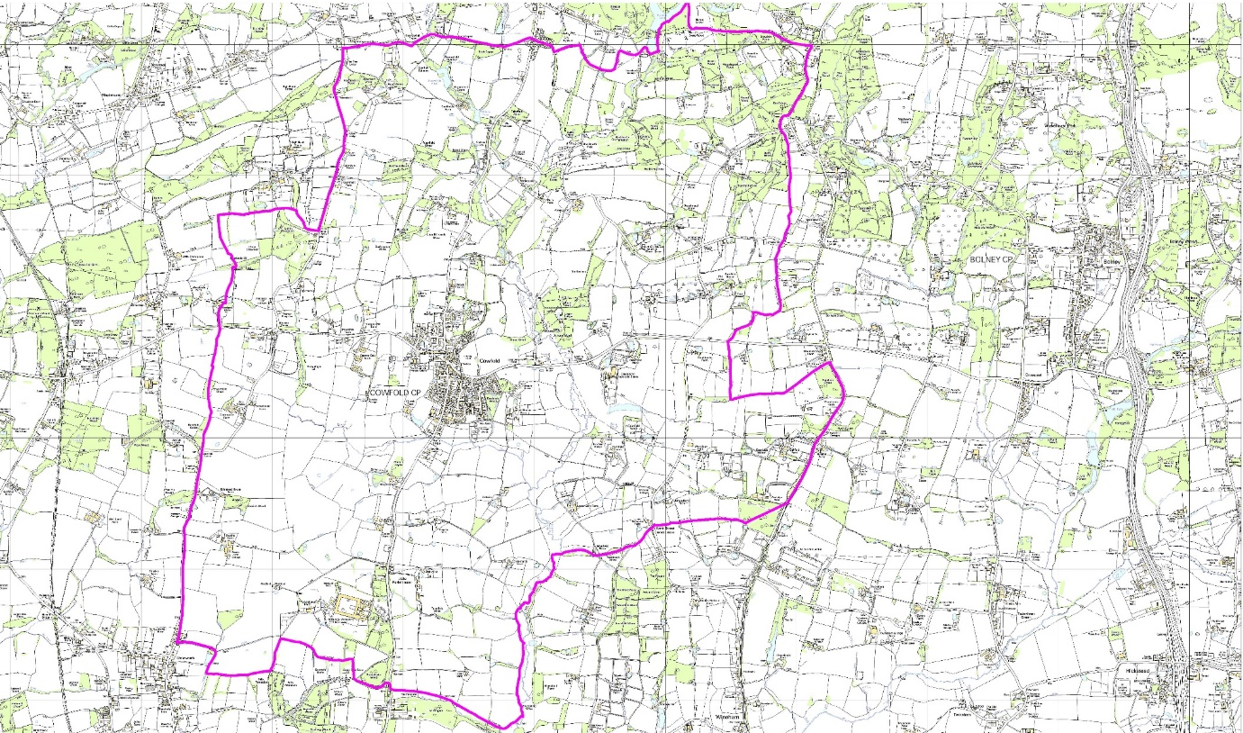
Digital Map from Dotted Eyes Crown Copyright Licence No: 100002215

