**How We Teach Science at St Peter’s**



1. **Intent**

At St. Peter’s School, we believe that becoming a good scientist is not only about depth of scientific knowledge, but also being able to use a range of enquiry skills. These enable children to confidently, inquisitively, independently and passionately learn more and gain more from the world around them. The enquiry skills are the Essential Characteristics that underpin how our science curriculum is delivered, and also serve to support collaborative skills, our Christian Values and the development of a Growth Mindset.

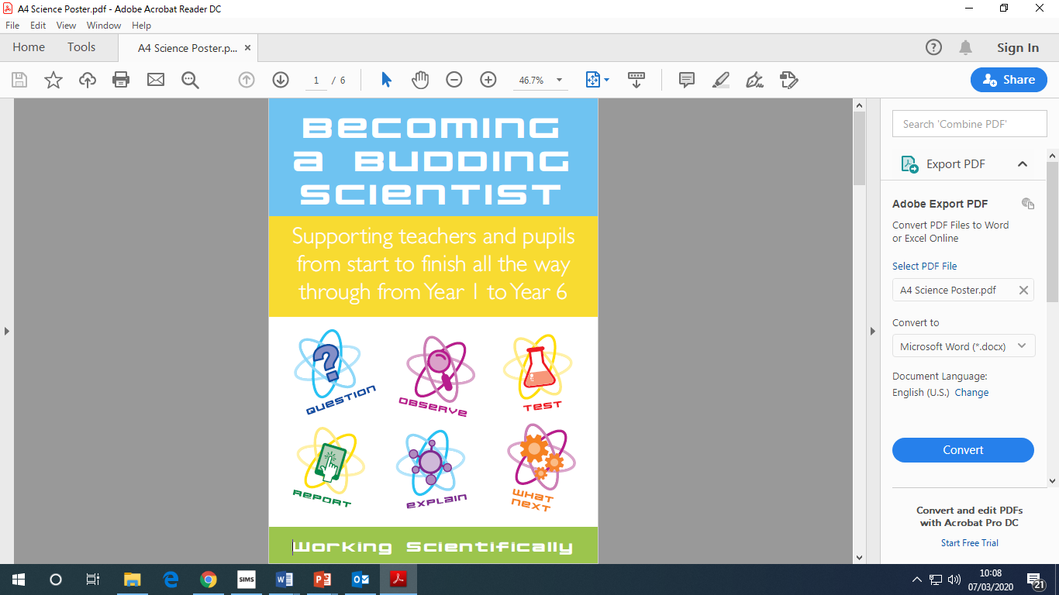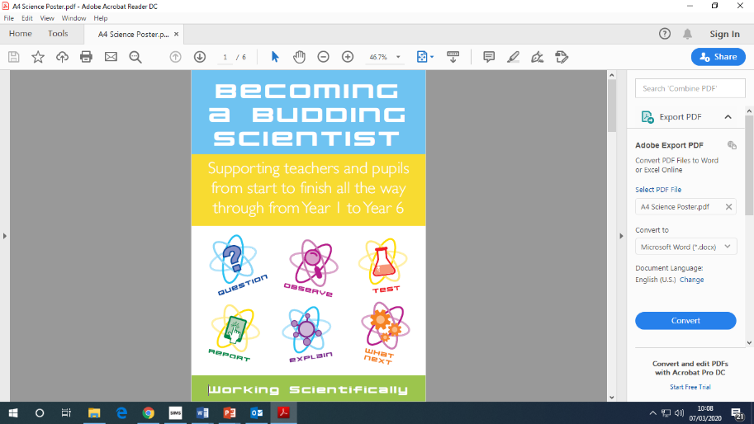

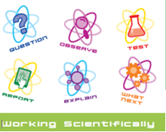



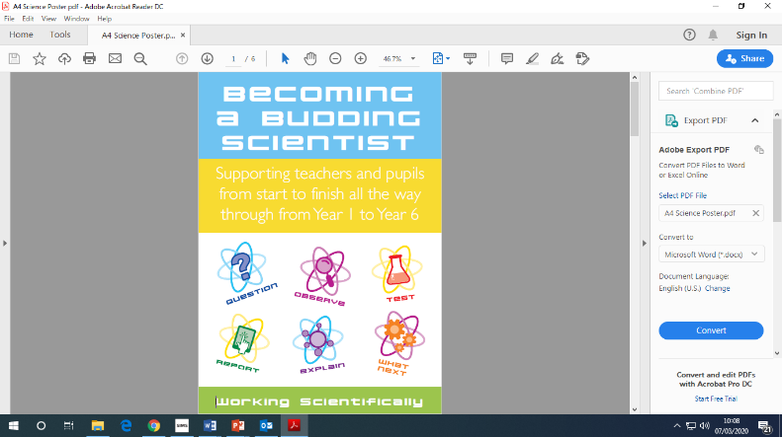 Our Christian Values inform and guide everything we do at St Peter’s, including our planning and delivery of Science. We teach children the ability to think independently and raise questions, enabling us to embark on a learning adventure together.

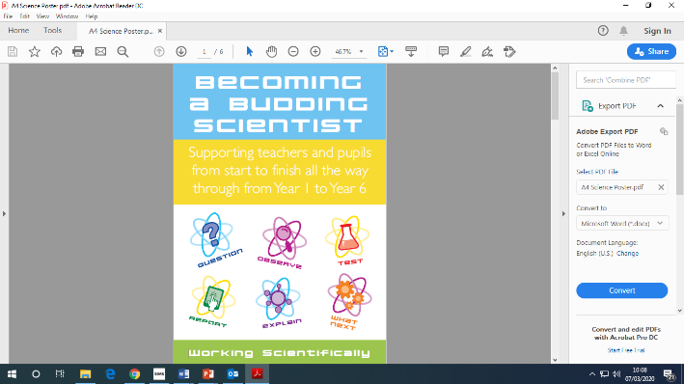We encourage children to make careful observations, to test and investigate their their ideas ***creatively***, developing their love for learning. We acknowledge the importance of developing faith and confidence in themselves and others, so they have the ***courage*** and ***perseverance*** when things don’t go quite as expected, and the ability to ***reflect*** upon our outcomes so we can plan for the future.



Good quality scientific learning is vital to every child’s development, because it is not just about the science. Science does not stand on its own, but through its vast wealth of skills and knowledge can support and interweave into every other subject; maths or geography, for example; giving it greater depth and purpose. Scientific Enquiry skills are skills for life-long learning, and this begins at Early Years. The EYFS explain that ‘exploring’, ‘having their own ideas’ ‘choosing ways to do things’ are key characteristics of effective learning. These are very similar to the Scientific Enquiry skills ‘observing’ ‘asking questions’ or in year 6 ‘plan enquiries, including recognising and controlling variables where necessary.’ At St. Peter’s, we give them opportunities in our planning to demonstrate and develop their deeper understanding, to test what they know, and to learn from our fabulous mistakes. They are given opportunities to succeed, but also opportunities to push themselves to take risks in their investigative work, so that they can fail in a safe environment and learn from it. Children need to be ‘willing to have a go’, and so do we, otherwise we miss all those opportunities to talk about it and ask the important questions. We also want to fuel and drive children’s ambition to succeed, by giving them an age appropriate appreciation of the vast and wide-ranging employment opportunities a love for science can provide.

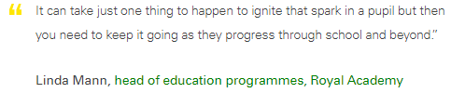

It takes more than being inspired to enable children to truly see themselves as scientists. At St. Peter’s we aim to ground them in science-based knowledge and understanding, experience of science related roles and professions and a positive attitude. Through development of this scientific capital, we hope to give them confidence to aspire to work at a local, national or global level- or beyond!

1. **Implementation - The Essentials Curriculum – Chris Quigley Approach**

At St Peter’s, The Essentials Curriculum allows us to turn the intent of ‘Our Curriculum Drivers’ in to reality for the children. We use ‘The Essential Characteristics’ of a Scientist to be the driving force behind the scientific activities we plan and teach.

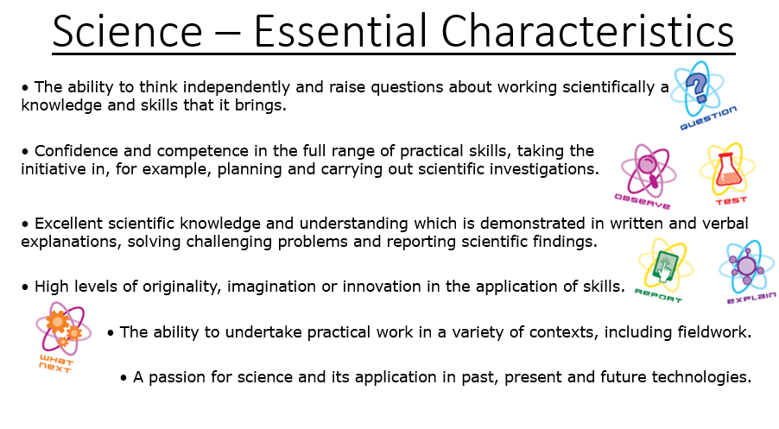

**2.1 Implementation - Curriculum Structure**

* **Essential Characteristics**

The things you need to show, do & understand to be a Scientist.

* **The Key Concepts**

The biggest ideas we can work at whilst we develop The Essential Characteristics.

* **The Context**

The topics we are going to study as we develop the above.

* **The Milestones**

The Essential Characteristics broken down into a progression of descriptors. Do them and you’ll gradually achieve those Characteristics. Milestone 1 is covered through years 1-2, Milestone 2 through years 3-5, and Milestone 3 through year 6.

* 1. **Key Concepts**

Over a three year period, at St. Peter’s we follow a Topic Cycle which ensures that the curriculum is covered by the end of each appropriate key stage. During this cycle, the key concepts of Biology, Chemistry and Physics (as shown below) will be covered, whilst the Key Concept of Working Scientifically will be incorporated into all the other key concepts of scientific learning in order to continually develop these skills.

These Key Concepts are further broken down into milestones, as shown:

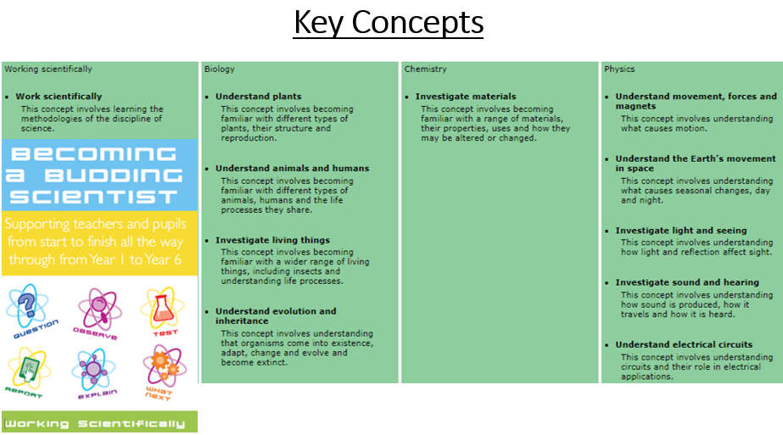

.

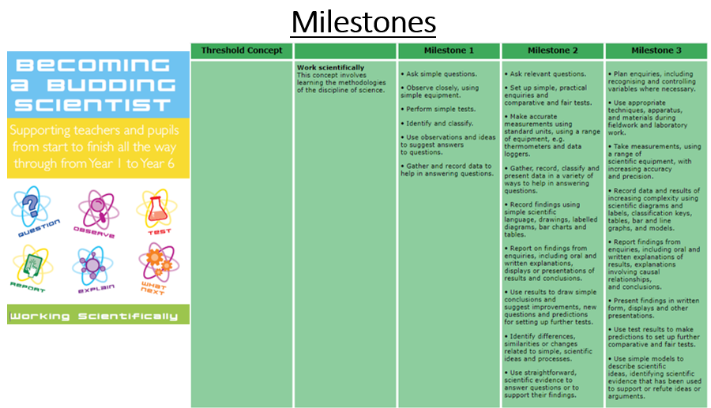

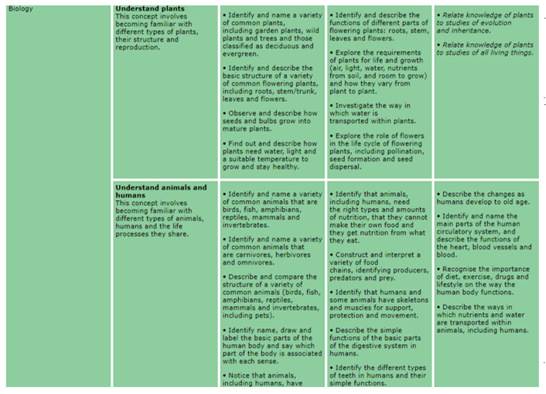

* 1. **An Example of Planning incorporating Key Concepts**

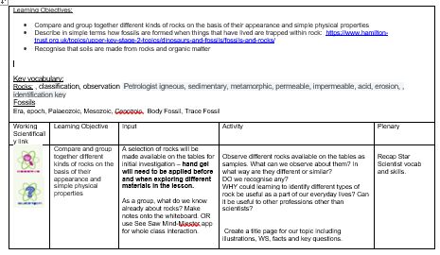

This is an example of KS2 planning linking to the topic of Romans, and covering ‘Investigating Materials- Rocks’ from the ‘Chemistry’ key concept.

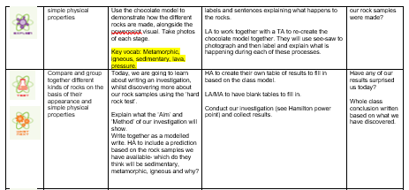

The planning also uses the WS Icons to reference those key concepts that will be integrated into the planning for those sessions.

* 1. **How We Ensure the Correct Coverage**

This has led to us ensuring:

◼ The subject curriculum is designed and delivered in a way that allows pupils to transfer key knowledge to long-term memory. It is sequenced so that new knowledge and skills build on what has been taught before and pupils can work towards clearly defined end points.

**2.6 – Curriculum Structure In More Detail**

Our over-arching topic cycle is based around are mixed year group structure. For Reception, Year 1 and Year 2 there is a 3 year rolling cycle. As we have two classes for Years 3 to 5 we have a 3-year cycle for those 2 classes. Year 6 are on their own in a class so they have an annual cycle. Science is taught as a discrete subject, but where occasionally the scientific concepts that need to be covered fit in with the topic cycles, links with other areas of the curriculum are encouraged here.

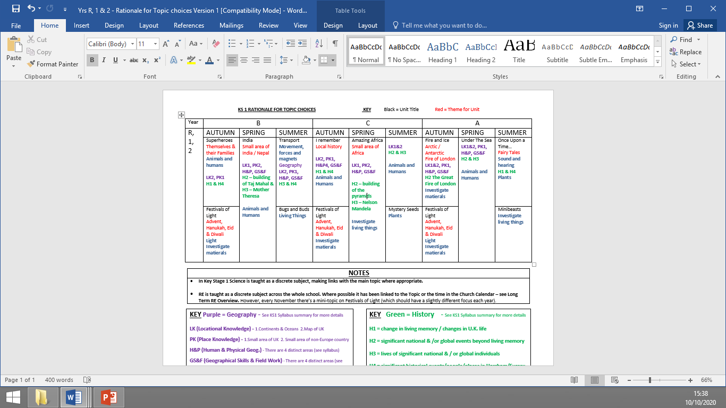

The subject of science consists of 11 **key Threshold Concepts.** One of these is the concept **Working** Scientifically, and the other ten **Key Threshold Concepts** are divided as seen below, into a three year cycle to ensure coverage across each key stage.

**Milestone 2: Year 3/4/5**

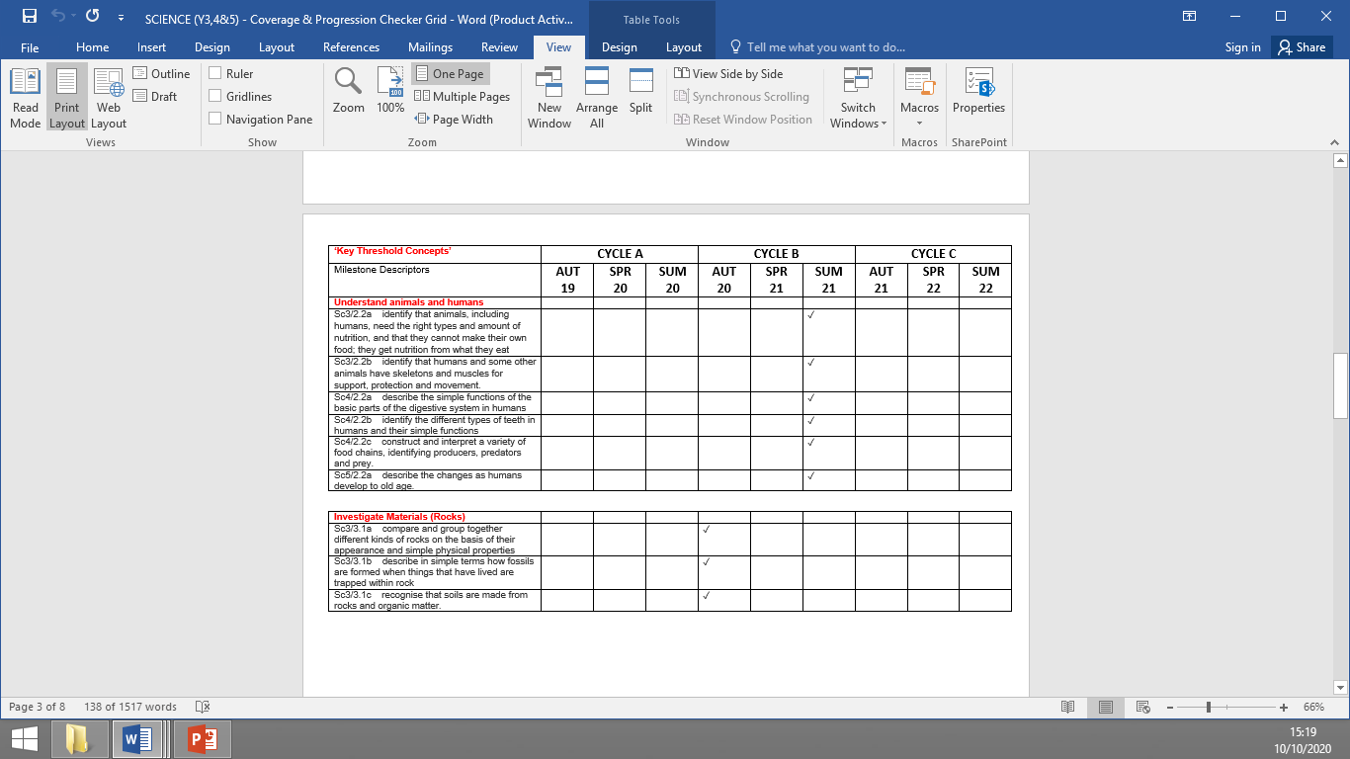

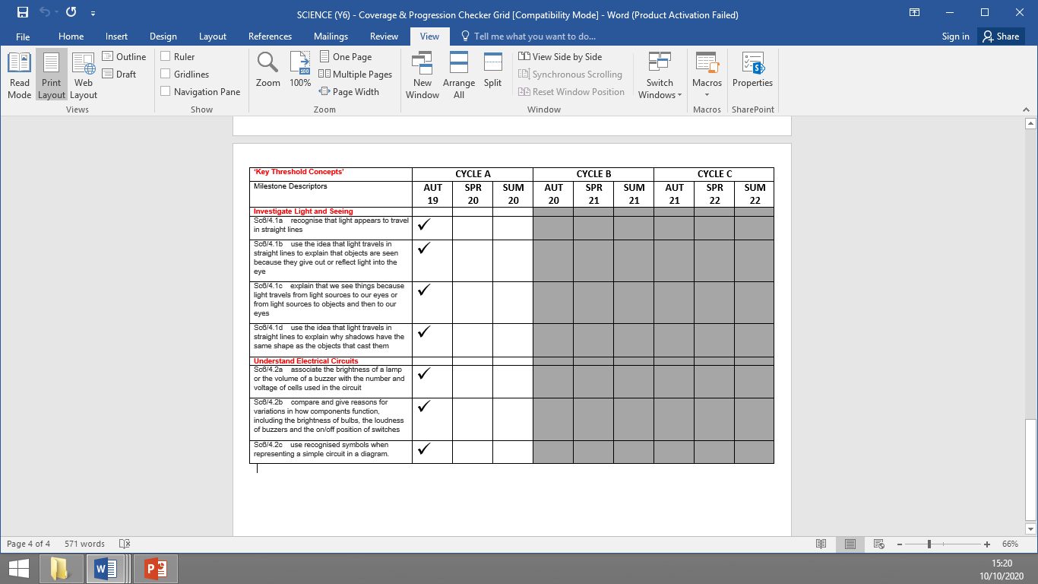 **Milestone 3: Year 6**

For The **Working Scientifically Key Threshold Concept**, the Milestone Descriptors are developed alongside the coverage identified below for the remaining **10 Key Threshold** **Concepts**. These are the skills that are the key to scientific thinking and opportunities to develop them should be considered in all science planning.

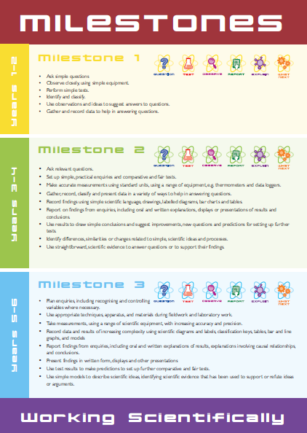Teachers should follow the progression of teaching ‘Working Scientifically’ scientific skills that is outlined in THE ESSENTIALS CURRICULUM (see poster to the left). These will be noted specifically in their medium term planning to ensure these are met and developed over the course of each academic year.

The objectives that go into these grids are drawn directly from the National Curriculum and from Chris Quigley’s Essentials Curriculum (2014) which is nationally recognised for its breadth and effective progression in coverage. The Essentials Curriculum covers and exceeds the requirements of the Primary National Curriculum for England (2014), leaving schools free to adapt the content. At St Peter’s we find using the Essentials Curriculum’s descriptors for these subjects breaks teaching and learning down into the more detailed skills and knowledge that pupils are expected to have at 3 Milestone points (Yr2, Yr4 & Yr6). That then enables teachers to teach in a carefully thought out progression that leads to greater pupil progress.

* 1. **Assessment in Science**

Assessing whether pupils have learnt what they are expected to learn (as laid out in the Milestone descriptors) will essentially be a practical ‘Assessment for Learning’ based approach, at St Peter’s.

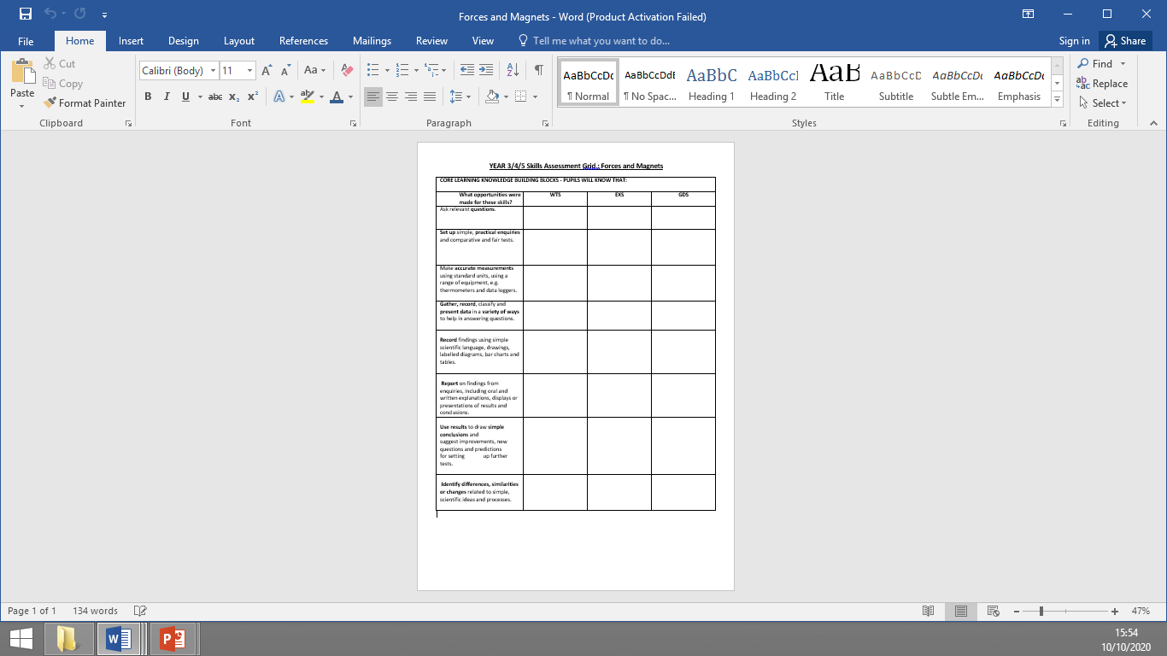Assessment Grids have been created based on the **working scientifically** Key concepts. This as because we believe that these are integral to children development a mind-set and approach which will support them in the future. Also, this key concept shows the importance of not just learning information, but also demonstrating an understanding of how to apply it. These Assessment grids will be completed every half term, and used to support planning for both individual pupils and the whole class during the next half terms work.

Teachers are also expected to record the coverage of the other key concepts in their planning, but also evidence it in the children’s books through WALTS or pupil assessment grids, which allow the children to be able to assess their own knowledge and learning development at the end of the lesson.

To ensure the standard of work and knowledge/ skills acquisition is in line (or exceeding) national expectations, regular monitoring will be done by The Subject Leader. In depth pupil interviews (with books), planning scrutiny and work scrutiny assesses whether the children have learnt what we set out to teach. Finding will be fed back to staff and governors – and where we can improve further, we will.