9th May 2018
SATS TIMETABLE AND YEAR 6 BBQ

Dear St Paul’s Class Parents and Children,

I am just writing to give you all the timetable for next week’s SATS and to tell you the details of the BBQ which we traditionally do on the Friday after SATS.
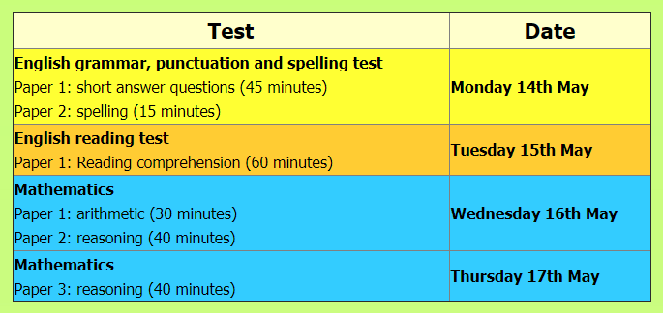

All of St Paul’s Class have done amazingly this year and all the children are really well prepared for SATS.

Children, now you can all ‘enjoy’ the week and show all that you know. Get plenty of sleep the night before the tests and don’t worry about them. We can’t ask more than for you to do their best, like you always do.

Importantly, we get to celebrate all the hard work you’ve put in by having a BBQ, which FoSPS are paying for, on Friday 18th May.

So, the children do not need a packed lunch, or a school dinner, that day. If any child has any food allergies please indicate on the slip below. Thank you.

Good luck everyone!
Yours sincerely,
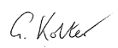

Giles Kolter Rhoda Wilson
Headteacher Senior Teacher

YEAR 6 BBQ

Child Name:……………………………………………………………..

Has the following dietary requirement:………………………………………………………………………………

Signed: …………………………………………

