7th September 2018

Art Club

Dear Parents and Pupils

We are delighted to offer an Art Club this term. It will be on Tuesdays and have a maximum of 14 children (names may need to be drawn from a hat if oversubscribed). There is a £15 charge to cover the cost of materials.

Children of all ages are welcome (Years 1 to 6).

There will be 2 projects per term, one for each side of the half term, with the pupils working towards a final piece after experimenting with difference techniques. The aim is to display the final artwork in the school on the wall (or table top if a sculpture).

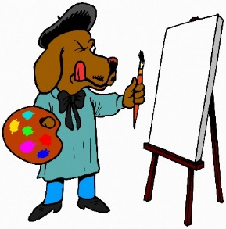
The first project will be based on Andy Goldworthy’s land art, which will also tie in nicely with Autumn!

We hope to see you there!

Mrs Nelson and Mrs Lawrence

……………………………………………………………………………………………….....

Art Club – Autumn Term 2018

Child/ren’s name:_____________________________________ Class:___________

I would like the above child/ren to take part in the Art club commencing Tuesday 25th September 2018 and enclose £15 exact cash/or cheque (please make cheques payable to Mrs Sarah Lawrence)

In the event of a session being cancelled I am happy to be contacted by text message.

Parent contact mobile number ___________________________________________

Parent email address __________________________________________________

Signed:_______________________________________________________ (Parent)

