 | APPLICATION FOR ENTRY TO  St. Peter’s C of E (Aided) Primary School  Potters Green, off Station Road, Cowfold, Nr Horsham, West Sussex RH13 8QZ  Tel No: 01403 864365  E-mail: office@stpeterscowfold.uk  Headteacher: Mr Giles Kolter BSc(Hons) PGCE NPQH
ADMISSION ARRANGEMENTS / POLICY – 2025-2026

The School Governing Body is the Admissions Authority for the School. The Governors’ wish is that the school should aim to meet the educational needs of the children of all those families within the village seeking places at the school and of families with children already attending the school before offering places more widely. The Published Admissions Number (PAN) is 20. Where the number of admission applications received is 20 or fewer, a place will be offered for every child without condition. If the number of applications exceeds 20, the order of priority for admission will be determined by the application of the following oversubscription criteria:

Before applying the over-subscription criteria, a place will be allocated for any child with an Education Health and Care Plan (EHCP) that names St Peter’s CofE Primary School, Cowfold, as the school the child must attend. This place will be allocated within the Published Admission Number, (PAN), before the consideration of any other applications, or above the PAN if places have already been offered at that time. If more parents express a preference for the school than the published number of places for new admissions, the LGB will use the following criteria to rank applications and allocate places:

Oversubscription Criteria
- A ‘looked after child’ or a child who was previously looked after but immediately after being looked after became subject to an adoption, child arrangements, or special guardianship order* including those who appear [to the admission authority] to have been in state care outside of England and ceased to be in state care as a result of being adopted. A looked after child is a child who, at the time of application, is (a) in the care of a local authority, or (b) being provided with accommodation by a local authority in the exercise of their social services functions (section 22 (1) of the Children Act 1989 applies). This includes children who were previously looked after but immediately after being looked after became subject to an adoption, residence, or special guardianship.
- Children who have at least one parent who worships at the Parish Eucharist at St Peter’s Church, Cowfold at least twice every month for a minimum period of six months prior to application, and who are resident within the ecclesiastical Parish of Cowfold.
- Children who have siblings at the school at the time of admission and who are resident within the ecclesiastical Parish of Cowfold.
- Children who have at least one parent who attends the main act of worship at another church (which must be a member of the Churches Together in Britain and Ireland or of the Evangelical Alliance) at least twice every month for a minimum period of six months prior to application and who are resident in the ecclesiastical Parish of Cowfold. New residents may apply to their previous church for a reference.
- All other children of parents who are resident within the ecclesiastical Parish of Cowfold.
- Children with siblings attending the school at the time of admission, but who are not resident within the ecclesiastical Parish of Cowfold.
- Children who have at least one parent who worships at the Parish Eucharist at St Peter’s Church, Cowfold, at least twice every month, but who are not resident within the ecclesiastical Parish of Cowfold.
- Children who are not resident within the ecclesiastical Parish of Cowfold, but have at least one parent who attends the main act of worship at another church (which must be a member of the Churches Together in Britain and Ireland or of the Evangelical Alliance) at least twice every month for a minimum of six months prior to application. New residents may apply to their previous church for a reference.
- Any other children not included in the above criteria.

Allocating Places
In the event of any of the above categories being over-subscribed, the Local Governing Body will take those children whose home address is nearest to the school / academy measured by the Local Authority’s computerised measuring system. In the case of flats, all applicants will be treated as equidistant from the school. The Local Authority’s computerised measuring system will be used to determine these distances.

Tiebreaker
In the event that applicants for the last place(s) cannot be prioritised using distance as detailed above, above because the distance measurements are the same, the Trust will use random allocation to decide which children will be offered the remaining place(s).

Notes:
- In accordance with National SEN Code of Practice, we will accept any child with St Peter's School named in their Education Health and Care Plan (EHCP) into the school.
- Multiple birth children (for example: twins or triplets) would not be separated. If one child were ranked at number 20 so would all the other children, and the school would exceed its PAN.
- *An adoption order is an order under the Adoption Act 1976 (see Section 12 adoption orders) and children who were adopted under the Adoption and Children Act 2002 (see Section 46 adoption orders). A ‘child arrangements order’ is an order settling the arrangements to be made as to the person with whom the child is to live under Section 8 of the Children Act 1989 as amended by Section 14 of the Children and Families Act 2014. Section 14A of the Children Act 1989 defines a ‘special guardianship order’ as an order appointing one or more individuals to be a child’s special guardian (or special guardians).

Parish Map
A map showing the boundaries of the ecclesiastical Parish of Cowfold can be found at the end of these arrangements.

Deadlines & Waiting List
Applications submitted after the national deadline set by the government of 15 January will be considered after places have been allocated to those applications received on time. If the year group is oversubscribed, a waiting list of pupils will be maintained for the main September admissions round. Children on the waiting list, and any additional applicants, will be ranked according to the admissions criteria and each time a child’s name is added, the list will be re-ranked. This will be maintained until 31st December of the same year.

Appeal
There is a right of appeal to an independent panel against a decision made by the governors to refuse admission. Parents wishing to exercise this right should write to the Clerk to the Governors c/o the School. All appeals must be received within 20 school days of the receipt of the letter refusing a place.

Deferred Entry to School
While a child is below statutory school age, the parent may choose to defer his/her child’s entry to school until later in the school year. However, parents cannot defer beyond the point at which the child reaches statutory school age, or beyond the start of the last term in the school year.

Full Time or Part Time Start
A parent may apply for his/her child to start school for the first time in the September following their fourth birthday. Where a place is offered, a parent may choose for the child to start full time from day one, or to attend on a part time basis until statutory school age is reached (the start of the term after the child reaches their fifth birthday).

Applications made for children born from 1st April 2021 to 31st August 2021
Parents of a "summer born" child (born between the above dates) who is entitled to start school in September 2025 may request to delay his/her entry to Reception until September 2026 and this will receive consideration, although delayed entry will only be granted in very exceptional circumstances. The Headteacher should be contacted prior to any application where a delayed entry might be requested so that discussion of individual circumstances can take place.

Fair Access Protocol
The Governing Body adhere to the Fair Access Protocol as administered by West Sussex County Council.

In-Year Admissions
The Governing Body has delegated administration of In-Year Admissions to West Sussex County Council who will consult with the School’s Admissions Authority.

Admission of children outside of their normal age group
Parents may apply to the Local Governing Body to seek a place for their child outside of their normal age group, for example, if the child is gifted and talented or has experienced problems such as ill health.

Decisions for these requests will be made on the basis of the circumstances of each case and in the best interests of the child concerned. This will include taking account of the parent’s views; information about the child’s academic, social and emotional development; where relevant, their medical history and the views of a medical professional; whether they have previously been educated out of their normal age group; and whether they may naturally have fallen into a lower age group if it were not for being born prematurely. The views of the Headteacher will also be taken into account. When informing a parent of their decision on the year group the child should be admitted to, reasons for the decision will be clearly set out. It will be pointed out to parents that admitting a child into the school year below their chronological age, may result in them being past the statutory school leaving age of 16 before they do their GCSE exams. The school will seek written confirmation of the fact the parents acknowledge they have been informed about this.

Definitions
Governors have agreed the following definitions of words used in this policy:
Parents
Reference to parents includes legal guardians and applies to either or both parents, or a sole parent. Where only one parent/guardian satisfies a criterion, the application will be treated equally with one where the requirement is met by two parents.

Home address
The home address is where a child normally lives. Where a child lives with parents with shared parental responsibility, each for part of a week, the address where the child lives is determined using a joint declaration from the parents stating the pattern of residence. If a child’s residence is split equally between both parents, then parents will be asked to determine which residential address should be used for the purpose of admission to school.

If no joint declaration is received where the residence is split equally by the closing date for applications, the home address will be taken as the address where the child is registered with the doctor. Any other evidence provided by parents will also be considered in reaching a decision on the home address for admissions purposes. This may be necessary, for instance, where parents don’t agree on the child’s home address.

Sibling
A “sibling” refers to brother or sister, half brother or sister, adopted or fostered brother or sister, step brother or sister, or the child of a parent’s partner where the child for whom the School / academy place is sought is living in the same family unit at the same address as that sibling

If you use sibling as an OS criterion, decide if this refers to a sibling attending the school at the time of application, or who will be attending the school at the time of entry.

Staff
This includes all staff (teaching and non-teaching) appointed by the school (name of school/academy) including part-time staff with a continuous employment record and any short-term contract staff with a continuous employment record covering at least term time employment, for the 2 years or more prior to admission.

Church
This means a church that is a full member of the Churches Together in Britain and Ireland or of the Evangelical Alliance.

SUPPLEMENTARY INFORMATION FORM
FOR APPLICATION TO
St. Peter’s C of E (Aided) Primary School
Parents are requested to complete this form in addition to the West Sussex County Council (WSCC) online application.

APPLICATION FOR ADMISSION IN SEPTEMBER 2025
The purpose of this form is to enable us to rank the children in order of the Oversubscription Criteria set out on Page 1 of the Admission Arrangements. This would be important if the number of applications for Reception places exceeds the Published Admissions Number (PAN) in any given year.

NB: If you wish your application to be considered under criterion 2, 4, 7 or 8, please also complete the Church Members section overleaf.

Section 1 – ALL parents/carers are requested to complete this section

Please circle below the criterion you wish to make your application under. Please circle one category only.
1 | 2 | 3 | 4 | 5 | 6 | 7 | 8 | 9

CHILD’S DETAILS
Surname: |  |  |  | Forename:
Middle Name(s):
Date of Birth: |  |  |  | Male / Female*
Address:
Postcode: |  |  | Home Telephone No.:

APPLICANT’S DETAILS
Surname: |  |  |  | Forename:
Title: | Mr/Mrs/Ms/Miss/Mx* | Relationship to Child:
Address:
Postcode: |  |  | Home Telephone No.:

Email Address: ………………………………………………………………………………………………..
*Please delete as applicable

I understand that this form is not an offer of a place and that the information given is correct.
Signed: |  | Date:
(Parent/Carer)

SUPPLEMENTARY INFORMATION FORM
FOR APPLICATION TO
St. Peter’s C of E (Aided) Primary School
If you wish your application to be considered under categories 2, 4, 7 or 8, please complete the Church Members section below and return the form (section 1 & 2 completed) to the School.

If you wish your application to be considered under criterion 2, 4, 7 or 8, please complete the Church Members section below and pass this to the Parish Priest of St Peter’s Church, Cowfold for verification (or a Churchwarden, in the case of a vacancy or long term absence of the Vicar) or to your Church Minister for verification.

The completed Supplementary Information Form, (sections 1 & 2) should be returned by you to the school, for the normal admissions round or in-year admissions, if you wish your application to be considered against criterion 2, 4, 7 or 8.

SECTION 2 – Church Members
To be completed for applications under criterion 2, 4, 7 or 8.

PLEASE COMPLETE EITHER A OR B BELOW

A. | I confirm that at least one of the child’s parents have attended the Parish Eucharist at St Peter’s Church, Cowfold twice a month for a minimum period of 6 months prior to application.
Signed: |  |  | Date:
Parish Priest (or in the case of a vacancy or long term absence of the Parish Priest, a Churchwarden).

B. | I confirm that at least one of the child’s parents have attended the main act of worship at
B. |  |  |  |  |  | Church, at least twice a month,
 | for a minimum of 6 months prior to application. This church is a member of the Churches Together in Britain and Ireland, or of the Evangelical Alliance.
Signed: |  |  |  |  | Date:
Position Held:
Minister’s name: |  |  |  |  | Telephone:
Minister’s address:

Parish Map - Diocese of Chichester, Parish of Cowfold

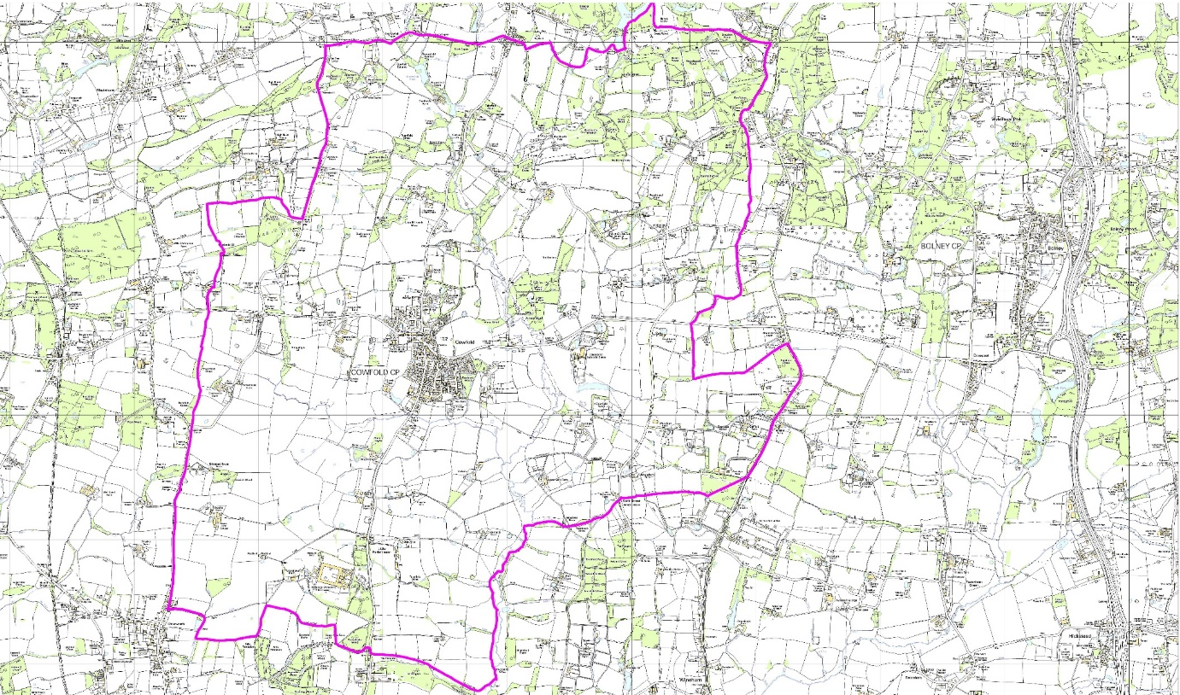
Digital Map from Dotted Eyes Crown Copyright Licence No: 100002215

