How to make a weather station
The purpose of our rain gauge was to set up an experiment to compare results and to be able to graph them – and the results were a big surprise for the children. When we set the rain gauge up I let the children lead and find a bottle they thought would be a good size. They were sure that on a very rainy day the bottle would be filled to overflowing! It was surprising to them to discover that a day that soaks the garden (and all the washing on the line!) actually only gave them half a centimetre of rain in their bottle.
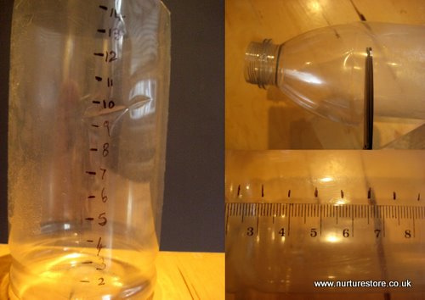

How to make a rain gauge
1. Find a bottle with straight sides and cut off the top
2. Use a ruler and a permanent marker to mark off a scale
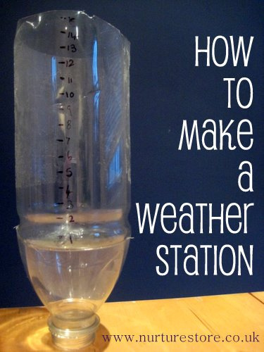
3. Superglue the cut-off top of the bottle upside down on the base of the bottle. This allows you to push the rain gauge down into some soil in your garden so the bottle doesn’t topple over or blow away
4. Check your rain gauge every morning and see how much rain has filled your bottle. Record your results on a bar chart. Empty all the rain out of the bottle and replace it so you can measure how much falls the next day
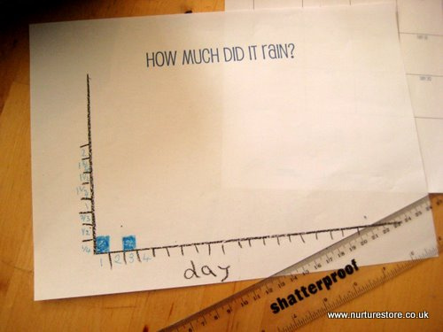
What children can learn: how to set up a simple experiment, how to measure data, how to record data, that things don’t always turn out as expected
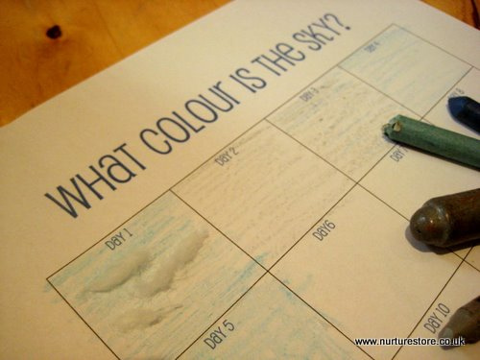

Weather station observation chart
1. We printed off a What colour is the sky?‘ chart
2. Each morning we looked at the sky to see what the weather was like that day. We tried to find exactly the right pen, pencil or crayon to colour in that day’s box on the chart so it looked just like the sky outside. (Sadly,we needed lots of grey.) We added in cotton wool clouds if there were any and looked up the names of different cloud formations. This made a patchwork picture of the weather for us.
What children can learn: observation skills, that the weather changes day by day, how ‘blue’ can be all sorts of shades, that clouds can be all different shapes and sizes and have special scientific names, that observing nature can translate into art.
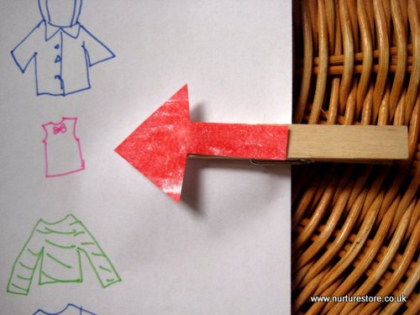

What Should I Wear? chart
What do changes in the weather actually mean to young children? To translate our observations into something relevant to their experiences we set up a ‘What should I wear?’ chart.
1. Create a tall chart showing different types of clothing your child might wear – you can draw them or take photos of your children’s actual clothes.
2. Sequence your clothing pictures from hot to cold. It could look something like this: sunhat, t-shirt, long sleeved top, extra vest, rain coat, winter coat, woolly hat, scarf and gloves, snow boots.
3. Cut out a big arrow and stick it to a clothes peg. Once you have completed your Weather Station Observation Chart for the day ask you child to think about what the weather means for what they need to wear that day. Peg your arrow marker to the right stage of your ‘What Should I wear’ chart, then go and get dressed and head out to play in the fresh air!
http://www.metoffice.gov.uk/media/pdf/r/f/cloud-spotting.pdf

